**PHASE 4**

**LESSON 2**

**PRACTICE ASSISTED 1**

**Source code:**

**Functions.html:**

<!DOCTYPE html>

<html lang="en">

<head>

    <meta charset="UTF-8">

    <meta http-equiv="X-UA-Compatible" content="IE=edge">

    <meta name="viewport" content="width=device-width, initial-scale=1.0">

    <title>Document</title>

</head>

<body>

    <script>

        //simple function

        function display(){

            console.log("Display is called");

            document.write("Display is called");

        }

        display();

        //parameterised function

        function arithmetic(a,b){

            var num1= a+b;

            var num2= a*b;

            return num1+num2;

        }

        var result = arithmetic(15,25);

        console.log("Result is: "+result);

        document.writeln("Result is: "+result);

    </script>

</body>

</html>

**Output:**

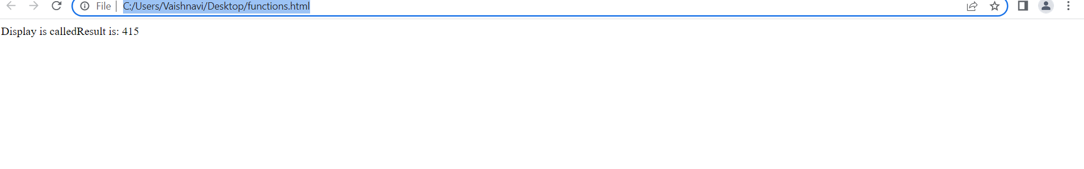

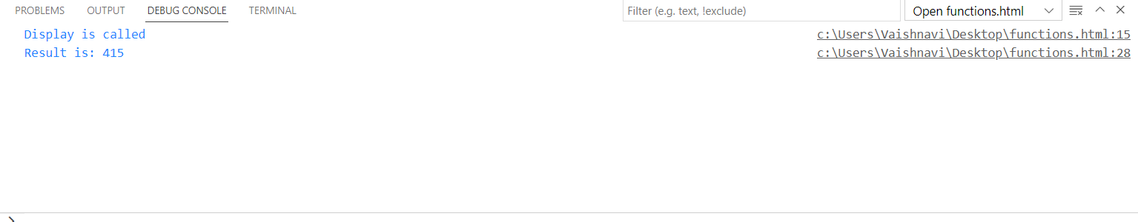

**Prototype.html:**

<!DOCTYPE html>

<html lang="en">

<head>

    <meta charset="UTF-8">

    <meta http-equiv="X-UA-Compatible" content="IE=edge">

    <meta name="viewport" content="width=device-width, initial-scale=1.0">

    <title>Document</title>

</head>

<body>

    <script>

        //function as constructor

        function Student(name, yearOfBirth){

            this.name = name;

            this.yearOfBirth = yearOfBirth;

        }

        // create prototype

        Student.prototype.calculateAge = function(){

            var age = 2022 - this.yearOfBirth;

            console.log("Age: "+age);

            document.write("Age: "+age);

        }

        //objext for function constructor

        var s1 = new Student("kav","2000");

        var s2 = new Student("Prabhu", "2001");

        //printing

        console.log(s1);

        s1.calculateAge();

        console.log(s2);

        s2.calculateAge();

    </script>

</body>

</html>

**Output:**



